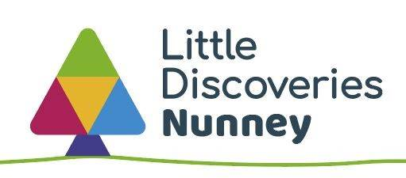

**Level 2 or 3 Early Years Practitioner**

**Little Discoveries Nunney**

**12 hours per week, term time only contract**

**Hourly Rate £11.60 - £12.00**

**Situated in Nunney, nr. Frome, Somerset**

Little Discoveries Nunney are looking for a passionate, kind and caring Early Years Practitioner to join our team for one day a week maternity cover (Wednesday) and one day a week permanent (Friday). There may also be opportunity to work in our sister nursery situated in Frome.

We are looking for someone who has experience within the early years sector with either a level 2 or level 3 relevant qualification.

We are committed to providing an inclusive working environment for all and are passionate and supportive in development our staff team to the full.

This is an exciting role where you will join a small friendly team and share your ideas, activities with us all; along with learning about what our curriculum has to offer, what we would like the children to learn, and nurturing children’s love for learning.

We are situated within the small village of Nunney and based on the Nunney First School site. The nursery provides care for a maximum of 24 children daily, age ranging between 2-4 years on a term time only basis.

Our operating hours are 8.30pm – 3.30pm. Hours for this post would be 8.30am - 3.30pm Monday and Wednesday.

To apply, please send a copy of your CV and confirmation of your desire to be considered for the role to **Sadie Marsh – Nursery Manager at** [nunney@sslcic.co.uk](mailto:nunney@sslcic.co.uk). If you would like an informal discussion about the post, or to arrange a look around the setting, please contact Sadie or call **01373 836353.**

We will review applications as they are received so, please apply as soon as possible. Final closing date for applications 28th February 2025.

Little Discoveries - Nunney & SS&L are committed to the protection of young people and vulnerable adults and to safeguarding and promoting the welfare of learners and expect all staff to share this commitment. Nunney and SS&L recognises the positive value of diversity, promotes equality and challenges discrimination.

We welcome and encourage job applications from everyone.

*This post is subject to satisfactory references and a DBS enhanced check.*